**Introduction**

The client Financial institution engaged security consultants to do a vulnerability assessment on its public facing website hosting financial web applications and sensitive data.

According to a 2021 Verizon's Data Breach Investigations Report (DBIR), the leading data type compromised within the financial services industry is personal - 83%, followed by bank data - 33% (Verizon, 2021). The financial services industry is heavily dependent on customer's personal data and payment card data. In addition, security breaches and data loss can cause reputational damage to the company, hence security is a priority for any company offering financial services. Since the financial sector relies heavily on the implicit trust between itself and the customers, it is especially susceptible to loss of confidence due to cyber-attacks.

Majority of the cyber-attacks are targeted towards banks (91 percent of the attacks) followed by insurance companies (7 percent). Among the banking lines of business, retail banking is attacked 39 percent of the time and credit card services are targeted 25 percent of the time.

Financial institutions are bound by governance directives such as GDPR (general data protection regulation) and PCI DSS (payment card industry data security standard). By complying with PCI DSS, an entity can ensure that they have met the minimum requirements to protect payment card data. Similarly, by complying with GDPR, an organization can confirm the minimum requirements to secure the customer's personal data.

**Scope and Methodology**

The scope of the assessment only includes the financial website hosted in AWS cloud with the following URL [**http://ec2-184-73-185-129.compute-1.amazonaws.com**](http://ec2-184-73-185-129.compute-1.amazonaws.com)

The assessment is based on both static analysis and dynamic analysis methods

**Static Analysis**

* Implementation of user identification, authentication, authorization, and access control systems was assessed against general financial industry business requirements and web application best practices
* Data confidentiality and integrity by checking against current encryption standards and implementations
* Source based analysis of program code, scripts, html files, configuration files, directory lists allowing identification vulnerabilities not covered by protocol based dynamic testing approaches
* Security policies and procedures

**Dynamic Analysis**

* Systematic scan of ports, network protocols, web server OS and services
* Vulnerability patterns based on protocols such as network or HTTP, SSL/TLS etc.
* Validate security configuration settings, software versions and security shortcomings.

**Summary of Findings**



**Figure 1 – Summary of findings**

**Web Server Security Test Results**

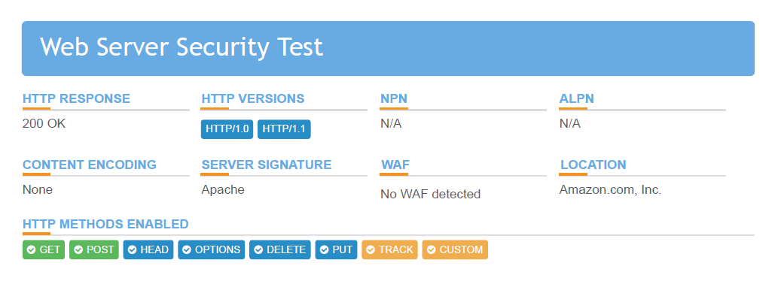

**Figure 2 – Web Server Security Test**

**GDPR Compliance Test Results**

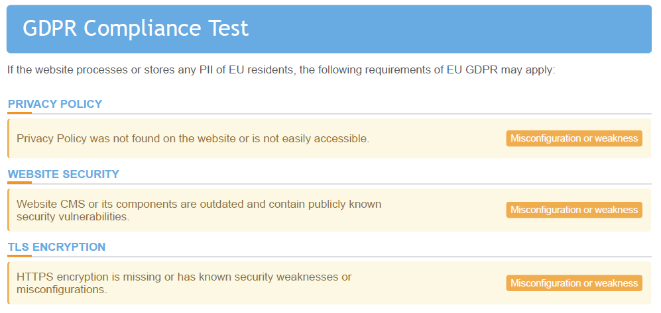

**Figure 3 – GDPR Compliance Test**

**PCI DSS Compliance Test Results**

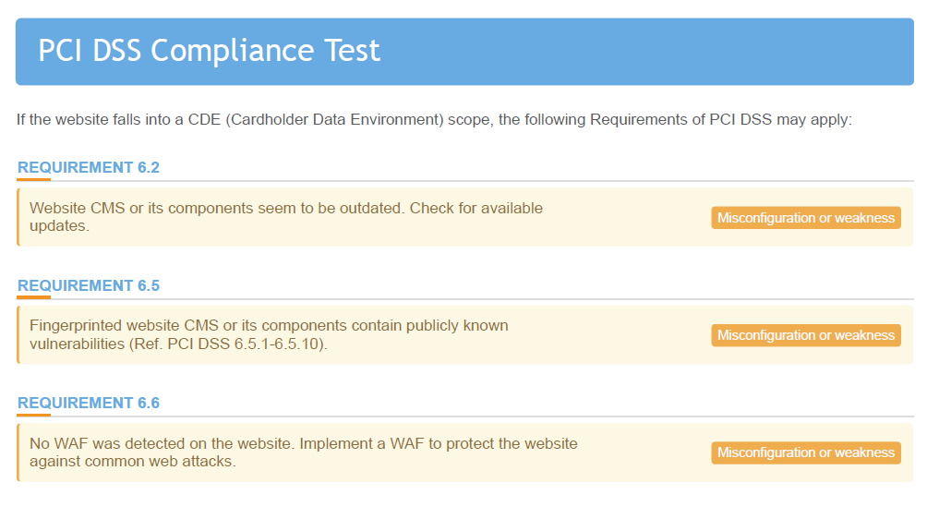**Figure 4 – PCI DSS Compliance Test**

**HTTP Headers Security Test Results**

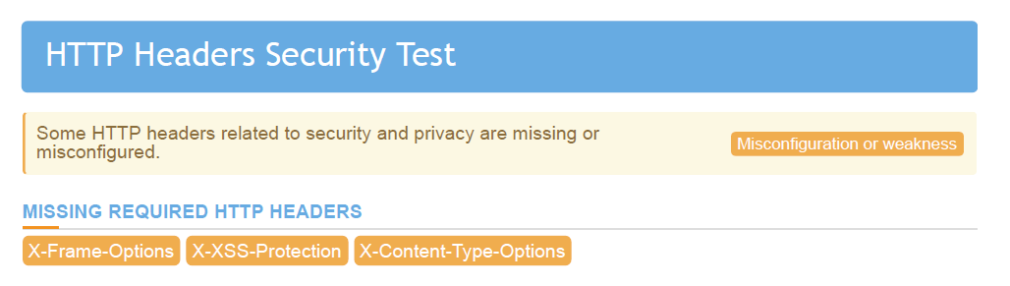

**Figure 5 – HTTP Headers Security**

**Software Security Test Results**

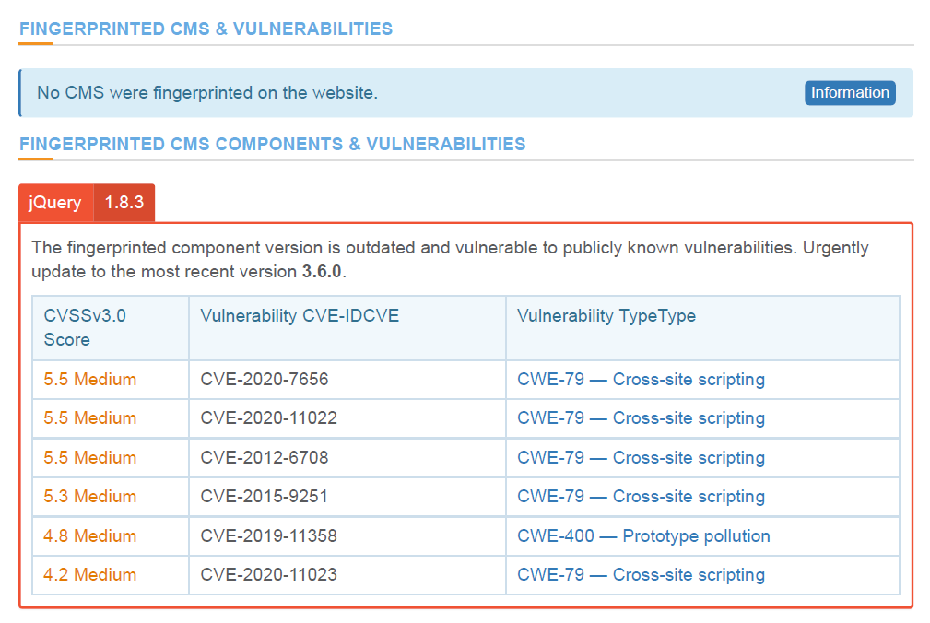

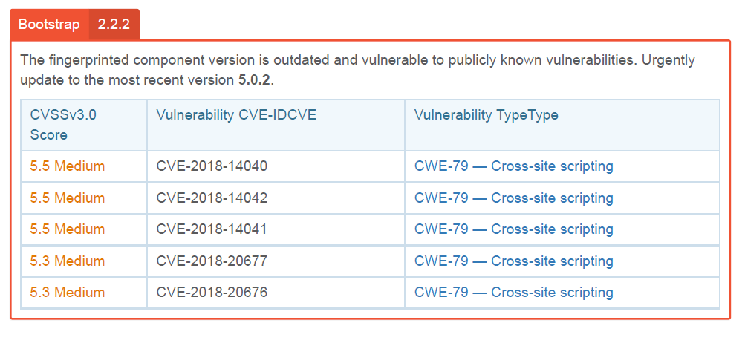

**Figure 6 – Software Security - CMS and WEB Vulnerabilities.**

**General Data Protection Regulation (GDPR)**

By complying with GDPR, an entity can confirm the minimum requirements to secure the customer's personal data.

The data governance and compliance practices should include people, processes, and technology (Olavsrud, 2021). Therefore, evaluating the website for compliance with security standards requires a more holistic approach than just technical assessment or scanning activities. The evaluation steps should include reviewing various policies, standards, and procedures. In addition, interviewing and inquiring members from senior management, middle management, subject matter experts, and employees also should be included within the evaluation process.

GDPR unites data privacy​ laws across the European Union (EU). The objective of the GDPR is protecting citizen's personal data, with the interests of the individual at its core. To evaluate the financial services website against GDPR, identifying personal data and data flow within the website.

Personal information can be identified by performing data discovery scans or using Data Loss Prevention Solution (DLP). After personal data is identified within the website, GDPR related requirements can be verified.

|  |  |  |  |
| --- | --- | --- | --- |
| **Goals** | **GDPR Reference Article** | **Website Evaluation Against GDPR\*** | **GDPR Evaluation Results\*\*** |
| Accountability Governance | 5(2) 7(1) 37(5,7) 38(1-6) 39(1,2) | Onsite Assessment | N/A |
| Processing Principles | 5(1) 6(1,2,3,4) 9(1,2) 10 24(1,2,3) | Onsite Assessment | N/A |
| ***Privacy by Design and Default*** | ***24(1): Responsibility of the controller***  ***25(1,2): Data protection by design and by default***  ***32(1,2,4): Security of processing*** | Onsite Assessment | ***Non-compliance:***  ***Privacy Policy was not found on the website or is not easily accessible.*** |
| Data Protection Impact Assessment | 35(1,2,7,9,11) 36(1,2,3) | Onsite Assessment | N/A |
| Records of Processing | 30(1,2,3,4,5) 31 | Onsite Assessment | N/A |
| Data Subject Rights | 15(1,2,3,4) 16 17(1,2,3) 18(1,2,3) 19 20(1,2) 21(1,2,3,4,6) 22(1,2,3,4) | Onsite Assessment | N/A |
| Consent and Notices | 7(1,2,3) 8(1,2) 12(1,3,4,5) 13(1,2,3,4) 14(1,2,3,4,5) | Onsite Assessment | N/A |
| Breach Management | 24(1,2,3) 32(1) 33(1,2,3,4,5) 34(1,2,3) | Onsite Assessment | N/A |
| Processors | 24(1,2,3) 25(1) 28(1,2,3) | Onsite Assessment | N/A |
| ***Data Transfers*** | ***32(1): Security of processing***  ***44: General principle for transfers***  ***45(1,8): Transfers based on an adequacy decision***  ***46(1,2,3): Transfers subject to appropriate safeguards***  ***47(1,2): Binding corporate rules*** | Technical Assessment:  ***Encrypt data encryption; and Secure data transfer methods*.**  Onsite Assessment | ***Non-compliance:***  ***The website is using HTTP instead of HTTPS. All requests and responses can be read by anyone who is monitoring the session.***  ***Website CMS or its components are outdated and contain publicly known security vulnerabilities.*** |

**\* Onsite Assessment** includes the review of website, policies, standards & procedure, and interviews various stakeholders.

** **N/A** indicates, unable to determine due to insufficient data.

**Payment Card Industry Data Security Standard (PCI DSS)**

By complying with PCI DSS, an organization can ensure that they have met the minimum requirements to protect payment card data. Identifying the payment card data and cardholder data environment (CDE) within the network is a critical step. A data flow diagram can be used to determine the in-scope systems and flows of data (Calver, 2018).

If any third-party service providers are used within the CDE environment, that is essential to ensure that the service providers comply with PCI DSS requirements (PCI Security Standards Council, 2018). This can be attained by using audit reports completed by reputed audit firms.

Amazon Web Services (AWS) compliance status can be obtained from the AWS website. According to the AWS site, AWS is certified as a PCI DSS Level 1 Service Provider.

|  |  |  |  |
| --- | --- | --- | --- |
| **Goals** | **PCI DSS Requirements** | **Website Evaluation Against PCI DSS** | **PCI Evaluation Results** |
| Build and Maintain a Secure Network and Systems | 1) Install and maintain a firewall configuration to protect cardholder data | Review the website architecture diagram  Onsite Assessment | N/A |
| 2) Do not use vendor-supplied defaults for system passwords and other security parameters | Vulnerability Assessment.  Onsite Assessment | N/A |
| ***Protect Cardholder Data*** | 3) Protect stored cardholder data | Data Discovery Scans.  Onsite Assessment | N/A |
| ***4) Encrypt transmission of cardholder data across open, public networks*** | Technical Assessment:  ***Encryption.***  Onsite Assessment | **Non-compliance:**  ***The website is using HTTP instead of HTTPS. All requests and responses can be read by anyone who is monitoring the session  Note: Because the website didn’t host payment card data, this was not identified as PCI non-compliance by the PCI scan. However, as this is a financial service-related website, this will result in non-compliance.*** |
| ***Maintain a Vulnerability Management Program*** | 5) Protect all systems against malware and regularly update antivirus software or programs | Vulnerability Assessment.  Onsite Assessment | N/A |
| ***6) Develop and maintain secure systems and applications*** | Technical Assessment:  ***Vulnerability Assessment***  ***Application Security Assessment.***  Onsite Assessment | ***Non-compliance:***  ***Website CMS or its components seem to be outdated. Check for available updates.***  ***Fingerprinted website CMS or its components contain publicly known vulnerabilities (Ref. PCI DSS 6.5.1-6.5.10).***  ***No WAF was detected on the website. Implement a WAF to protect the website against common web attacks.*** |
| Implement Strong Access Control Measures | 7) Restrict access to cardholder data by business need to know | Technical Assessment:  Access controls related to cardholder data.  Onsite Assessment | N/A |
| 8) Identify and authenticate access to system components | Technical Assessment:  Authentication controls  Onsite Assessment | N/A |
| 9) Restrict physical access to cardholder data | Onsite Assessment | N/A |
| Regularly Monitor and Test Networks | 10) Track and monitor all access to network resources and cardholder data | Technical Assessment:  Network access controls.  Onsite Assessment | N/A |
| 11) Regularly test security systems and processes | Technical Assessment:  Penetration testing; Vulnerability scans.  PCI Certified Assessors  Onsite Assessment | N/A |
| Maintain an Information Security Policy | 12) Maintain a policy that addresses information security for all person | Onsite Assessment | N/A |

**\* Onsite Assessment** includes the review of website, policies, standards & procedure and interviews various stakeholders.

** **N/A** indicates, unable to determine due to insufficient data.

**Recommendations**

Following assessment, our recommendations for the vulnerabilities found throughout scanning follows the Open Web Application Security Project (OWASP) methodology. OWASP is a nonprofit foundation that builds a framework for vulnerability assessment using community-driven, open-source software projects to better define web-based vulnerabilities to direct the development of secure website design and web software (owasp.org, nd).

OWASP releases the OWASP top ten (A1-A10) to broadly categorize the top ten vulnerability categories. Vulnerability severity ratings are decided based on the OWASP Risk Rating Methodology seen in the table below; ranking areas such as technical impacts or exploitability on a three-tier scale, 3 being the most severe. While this list is not exhaustive and does not include all vulnerabilities assessed, it does represent the most urgent vulnerabilities to resolve.

|  |  |  |  |  |  |
| --- | --- | --- | --- | --- | --- |
| **Threat Agents** | **Exploitability** | **Weakness**  **Prevalence** | **Weakness**  **Detectability** | **Technical Impacts** | **Business Impacts** |
| **Application Specific** | **Easy: 3** | **Widespread: 3** | **Easy: 3** | **Severe: 3** | **Business Specific** |
| **Average: 2** | **Common: 2** | **Average: 2** | **Moderate: 2** |
| **Difficult: 1** | **Uncommon: 1** | **Difficult: 1** | **Minor: 1** |

**Figure 7: OWASP Risk Rating Methodology Table (OWASP, 2017)**

|  |  |
| --- | --- |
| **Vulnerability** | **Recommendation** |
| **Using HTTP provides an insecure connection between website and client browser**  OWASP Class: **A3** - Sensitive Data Exposure  OWASP Risk Score out of **10: 7** | HTTP traffic is insecure, the standard being HTTPS using TLS encryption. Configuring the web server to use HTTPS will ensure greater security between webserver and web browser.  Not only is this required to be PCI compliant, but it is also mandatory by GDPR; failure to provide encrypted traffic can result in heavy fines and penalties.  See **Figure 2 – Web Server Security Test** for vulnerability details |
| **Vulnerability** | **Recommendation** |
| **Missing Security Headers:**   * Content-Security-Policy (CSP) * X-XSS-Protection * X-Content-Type-Options * Mac OSX .DS Store Web Directory Listing * Anti-clickjacking X-frame-Options header   OWASP Class: **A6** - Security Misconfiguration  OWASP Risk Score out of **10: 6** | Security misconfigurations, such as missing security headers can be particularly damaging due to their presence up and down the application stack, from network services to server and database functions. Impact can range from unauthorized access to system data or function to complete system compromise.   * While each of these reflect distinct risks their resolution is often to enable, change or configure from the default setting. * Having a repeatable configuration process for hardening new websites can ensure these services and settings don’t go unchecked when designing a website. * Containerized architecture can prevent vulnerability bleed across a website in the event of compromise. * Anti-clickjacking can be resolved by configuring   See **Figure 5 – HTTP Headers Security** for vulnerability details |
|
|
| **Medium Severity Cross Site Scripting (XSS):**  OWASP Class: **A7** - Cross-Site Scripting  OWASP Risk Score out of **10: 6** | This highly exploitable vulnerability can be easy to detect and can have moderately severe impacts if left unchecked.  This is best resolved by:   * understanding the capabilities and limitations of the XSS protections offered by the frameworks used (Ruby on Rails, React JS, etc). Selecting a framework that incorporates preventative XSS measures will greatly improve security by default. * Enabling a Content-Security Policy is a very effective means to harden a website, especially if code injection vulnerabilities have been identified and policy is configured to prevent local file access to vulnerable libraries.   See **Figure 5 – HTTP Headers Security** for vulnerability details |
| **Vulnerability** | **Recommendation** |
| **Out of Date Components:**  **jQuery and Bootstrap**  OWASP Class: **A9** - Using Components with Known Vulnerabilities  OWASP Risk Score out of **10: 4.7** | This can be resolved through a well-defined patch tracking and management policy.   * The version of jQuery used is out of date and should be brought to latest version **3.6.0** * The version of Bootstrap is out of date and should be brought up to the latest version **5.0.2**   See **Figure 6 – Software Security - CMS and WEB** for vulnerability details |

**Figure 8: Ranked vulnerabilities and recommended solutions (OWASP, 2017)**

**Conclusion**

Personal data containing personal information of individuals and bank information data is the most compromised data type in financial industry. Vulnerability assessment is done to evaluate a system against known vulnerabilities and whether remedies or fixes can be identified and implemented

Vulnerability assessment is based on two methods: static analysis and dynamic analysis. Statistical analysis targets user identification, authorization, and authentication. It tests the confidentiality and integrity of data by checking against current encryption standards and implementations. The dynamic analysis deals with systematic scanning of ports, network protocols, and web servers. It also checks the validation of security configuration settings, software versions, and security shortcomings.

Financial institutions need to be bound by General Data Protection Regulation (GDPR). This is the regulation that deals with data protection and privacy. It addresses how personal data should be transferred. It aims at enhancing individual control of rights over one’s personal data. If an organization complies with GDPR, only minimum requirements to secure the customer's data are needed.

Outdated components like JQuery and Bootstrap on the amazon web services may lead to crashing down the site; this may eventually lead to customer complaints as they try to access the system, resulting in loss to a couple of them. To avoid such cases, regular software updates need to be carried out.

Security headers are crucial for the security of any website. Their presence protects the site against many attacks that the site may be exposed to. They protect against code injection and many other vulnerabilities.

**References**

owasp.org. (n.d.). *OWASP Foundation, the Open Source Foundation for Application Security*. Available at: https://owasp.org/ [Accessed 12 Jul. 2021].

OWASP Top 10 - 2017. (2017). *OWASPFoundation, the Open Source Foundation for Application Security*, OWASP, pp.1–25. Available at: https://github.com/OWASP/Top10/raw/master/2017/OWASP%20Top%2010-2017%20(en).pdf [Accessed 12 Jul. 2021].

Olavsrud, T. (2021) What is data governance? A best practices framework for managing data assets. Available from:<https://www.cio.com/article/3521011/what-is-data-governance-a-best-practices-framework-for-managing-data-assets.html> [Accessed 14 July 2021].

PCI Security Standards Council (2018) PCI DSS Quick Reference Guide. Available from:<https://www.pcisecuritystandards.org/documents/PCI_DSS-QRG-v3_2_1.pdf> [Accessed 14 July 2021].

Calver, N. (2018) Preparing for a PCI audit. Available from:<https://www.itgovernance.co.uk/blog/preparing-for-a-pci-audit> [Accessed 14 July 2021].

Intersoft Consulting. (2016) *General Data Protection Regulation.* Available from:<https://gdpr-info.eu/> [Accessed 14 July 2021].